|  |  |
| --- | --- |
| **NAME :** | C.TAMILSELVAN |
| **DEPARTMENT :** | INDUSTRIAL BIOTECHNOLOGY |
| **COLLEGE :** | GOVERNMENT COLLEGE OF TECHNOLOGY |
| **NAAN MUDHALVAN COURSE:** | DIGITAL MARKETING |
| **NAAN MUDHALVAN ID :** | 97FADE0391EBC3692F54A0E0525BDECC |

ASSIGNMENT ON DIGITAL MARKETING

1. Create a blog or website using blogspot and wordpress.Customize the theme design and post new article with 500 words.

Blogspot:

<https://www.blogger.com/blog/posts/7558127320703576366>

1. Create a New Facebook Business Page and post one social media poster for your brand.

<https://www.facebook.com/tamilselvan.t.7798>

1. Create and design a social media advertisement poster using canva

<https://dietbytamilselvan.blogspot.com/2023/10/infographic.htmL>

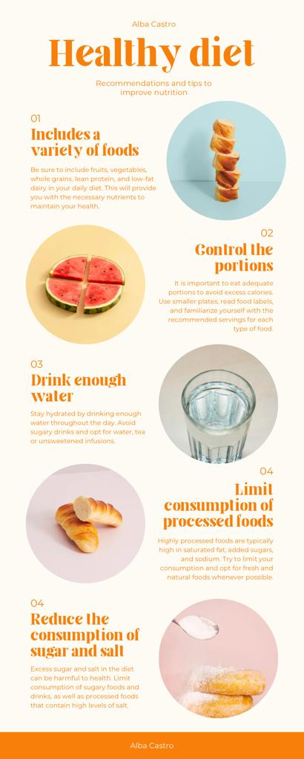

1. Create email newsletter design using MailChimp or canva tool.

<https://dietbytamilselvan.blogspot.com/2023/10/newsletter.htmL>

